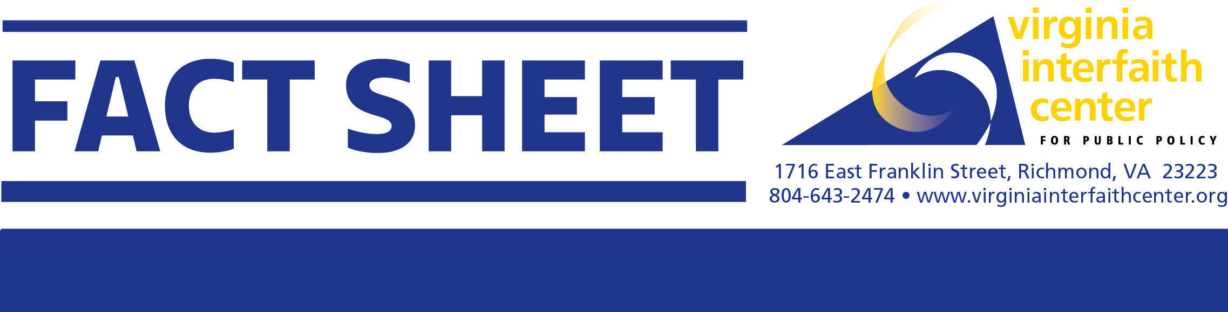
Problems: For most consumers, emails and phone calls are “free” with people’s internet or phone service plans. In Virginia’s prisons, those incarcerated are charged excessive fees for communication services and inflated prices for items purchased at commissaries. Emails are $.25 each, if purchased in bulk, or $.39 each if only five emails are purchased. Calls are $.0409 per minute ($2.45 per hour). Video calls are $4 for 20 minutes. The costs are primarily born by the families of incarcerated people. Virginians spent more than $50-million on commissary, telephone calls, video communications and media in VADOC in 2021. One in three families with an incarcerated member goes into debt to communicate with them. The families are incarcerated people are disproportionatey low-income families.
Stop Profiteering in Virginia’s Prisons

Those incarcerated need regular communication with children, parents and loved ones. Regular communication supports the well-being and mental health of those who are incarcerated and reduces recidivism of those who get released because they have been able to maintain family and community ties. Children have less trauma and improved outcomes if they can talk regularly with their incarcerated parents. Discouraging communication because of the exorbitant fees is costly to families and the society and short-sighted in terms of recidivism.

The reason why costs for basic communication and goods in the commissaries are so high is because well-connected firms are allowed to earn extravangant profits in exchange for commissions (kickbacks) to the prisons. Some sheriffs in Virginia have even received training cruises in the Carribean as part of the contracts.

Other states have developed approaches that allow for free or very low-cost emails, telephone calls and video calls, thus allowing those incarcerated to stay in regular contact with friends and family members without creating financial hardships.
Legislative Background: In the 2022 General Assembly, two bills (SB441 and HB665) passed to create a taskforce to review recommendations to eliminate or reduce the costs and fees to people incarcerated in the Virginia Department of Corrections (VADOC). The taskforce met throughout the summer and developed many recommendations to reduce exhorbitant fees and unnecessary costs. Even though there was broad agreement on the desire to reduce costs for families of people incarcerated, VADOC and community organizations representing people who are incarcerated and their families were not able to reach a consensus on most of the recommendations.

2023 Legislative Proposal: VICPP supports bills and budget amendments to:
- Provide no cost calls to people incarcerated or their family members.
- Increase the number of people on call lists from 15 to 20.
- Disallow VADOC commissions (kickbacks) from telephone, email and electronic visitation contracts.
- Limit upcharges in commissaries to 10 percent of the typical market rate charges for comparable goods.
- Provide work history, educational documents and medical documents without fees to those being released from prison.
- Limit the charges for electronic visiting to actual costs.
- Establish personal trusts accounts without predatory fees for when people are released from prison.

Primary source: Report from the taskforce, entitled Reduction or Elimination of Costs and Fees Charged to Inmates in State Correctional Facilities, Oct 1, 2022.

